Airflow Dag Assignment

- Output screenshot of data in the google sheet.
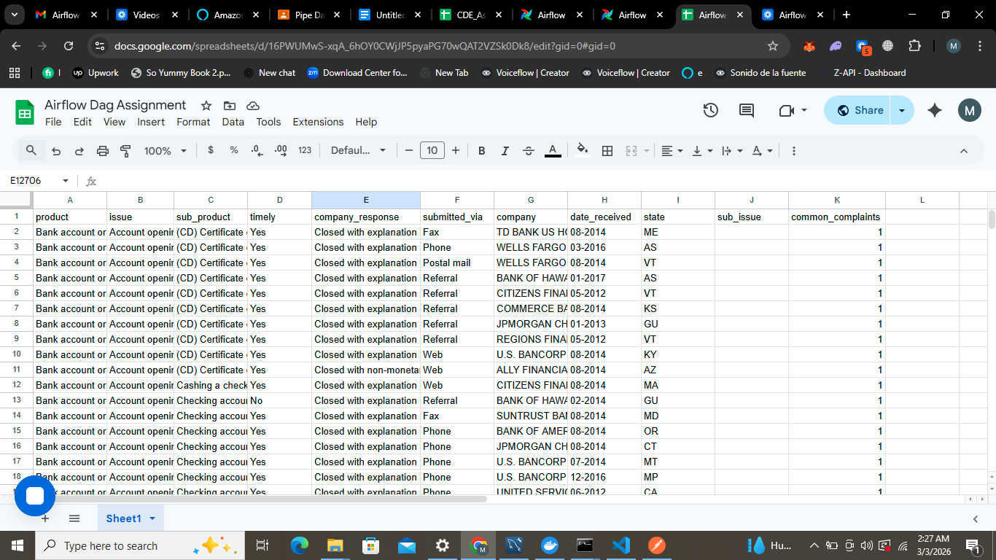
- Output of the emails received at the end of the task.
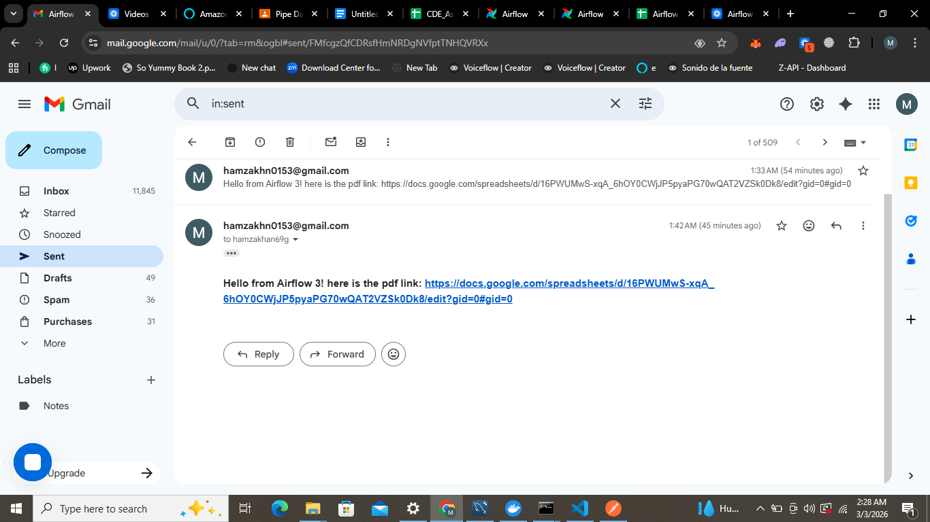
- Output of your dag graph view and grid view.
